# CVS Commercial Care - Caremark.com Member Live Chat

**Description:** CVS Commercial members have access to the memberlive chat functionality on Caremark.com. Members can now use the chat option instead of having to call or email Customer Care for assistance.

**Note:** This live chat functionality is being rolled out in waves – other lines of business will be notified when the member live chat functionality is available.

**Intended outcomes:**

* Improve member experience
* Reduce calls to Customer Care
* Reduce emails to eCare Team

**What if a member calls and asks to speak with who they were chatting to?**

* Advise the caller, “I am happy to assist, I am unable to transfer to a chat agent.”
* Attempt to resolve the member’s needs with first call resolution.
* Redirect members that insist on chatting to the website to use the chat function again.

**Can I see if a member has used the live chat function on Caremark.com in Compass?**

Yes! From the Member Snapshot Landing Page in Compass, the **Member’s Recent Cases** panel will show the most recent interactions with the member. The **green speech bubble** icon indicates that the member interaction was via chat:

Click the **View All Cases** link to navigate to the **Cases** page and view all interaction cases between other users and the member. The same icons will display in the **Case** column to indicate the different case types (Voice engagement, Email Engagement, and Chat):

** Where do members go to access the chat feature?**

Members can find the chat link on the lower right-hand side of the Caremark.com desktop website or on the right-hand side of the Caremark.com app.

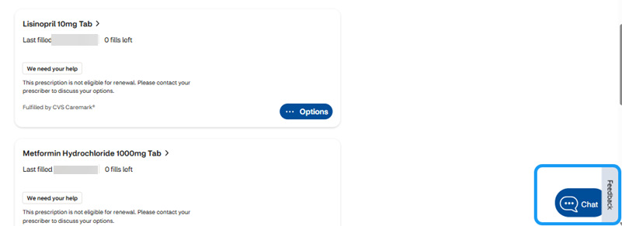

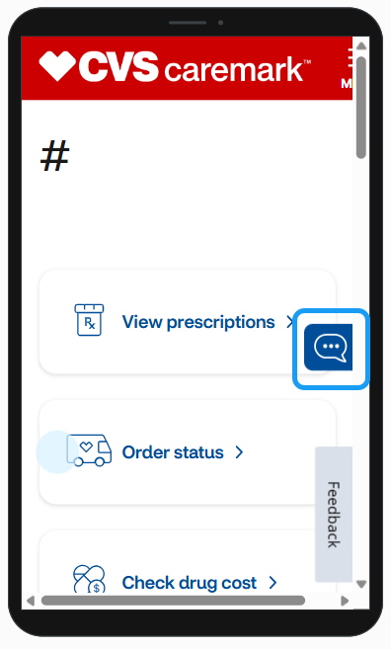

Top of the Document

Not To Be Reproduced Or Disclosed to Others Without Prior Written Approval

**ELECTRONIC DATA = OFFICIAL VERSION / PAPER COPY - INFORMATIONAL ONLY**